**(Structure in solidity | Struct in solidity):**

In Solidity, a **struct** is a user-defined data structure that allows you to group together different data types under a single name. It is similar to a record or a class in other programming languages. You can use structs to represent more complex data types by combining multiple fields.

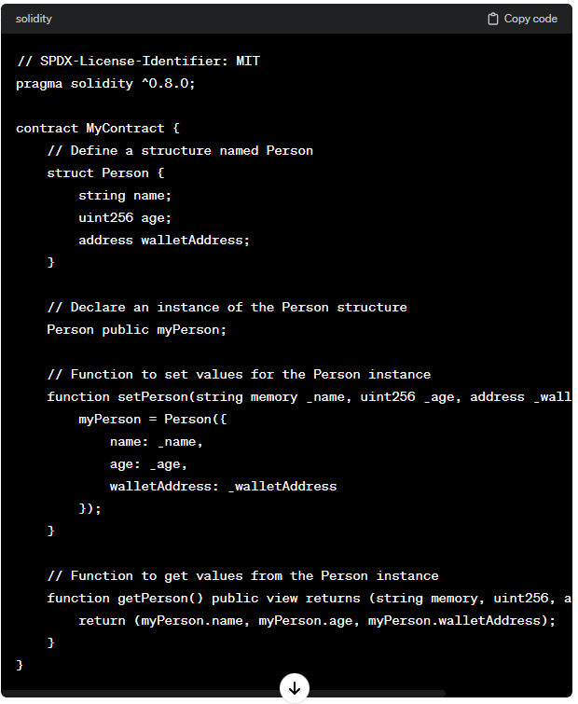

Remember that Solidity is designed for smart contract development, and you need to be mindful of gas costs and other considerations when writing code for deployment on a blockchain.

**Code:**

//SPDX-License-Identifier: GPL-3.0

pragma solidity >=0.5.0 < 0.9.0;

struct Student{

    uint roll;

    string name;

}

contract Demo{

    Student public s1;

    constructor(uint _roll,string memory _name)

    {

        s1.roll =_roll;

        s1.name =_name;

    }

    function change(uint _roll, string memory _name) public

    {

        Student memory new_student=Student({

            roll:_roll,

            name:_name

        });

        s1=new_student;

    }

}

**Output:**

